The Membership Form on this WEBSITE has been created by Microsoft Word 2010. This Form can be digitally signed. If you have difficulty assigning your digital signature then we will accept the Email Address this Form has been attached to as authorisation. If you are unable to Open the Microsoft Word Membership Form then please open and print off the PDF equivalent, this will have to be completed manually.
As there is a cost for setting up a Certified Digital Certificate if you don’t already have one we don’t expect you to go to this expense and a copy of your signature will suffice. This is quite easy to setup from Microsoft Word. Firstly you will need to scan or photograph your signature and save this on your PC
On opening the Membership Form you will notice this Form has been opened as Read Only. Click on “File” and then “Save As”. Recommend that you append your initials to the end of the current name being displayed

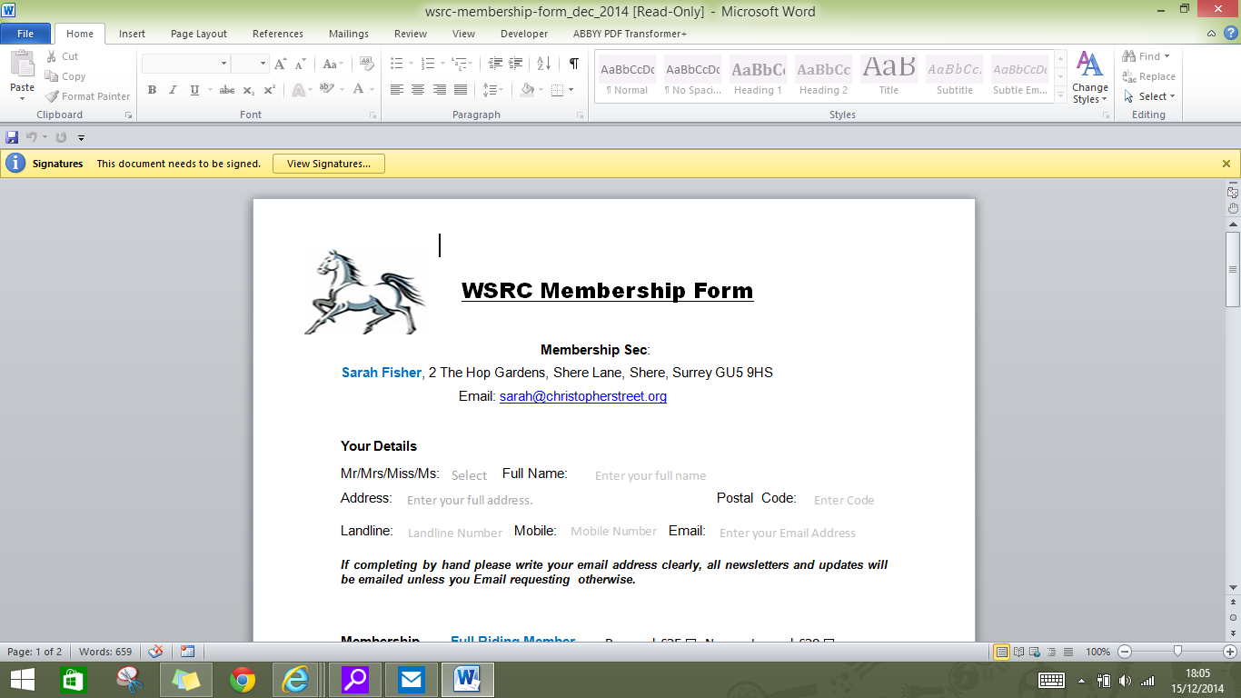

After you have saved this Form select “View Signatures”
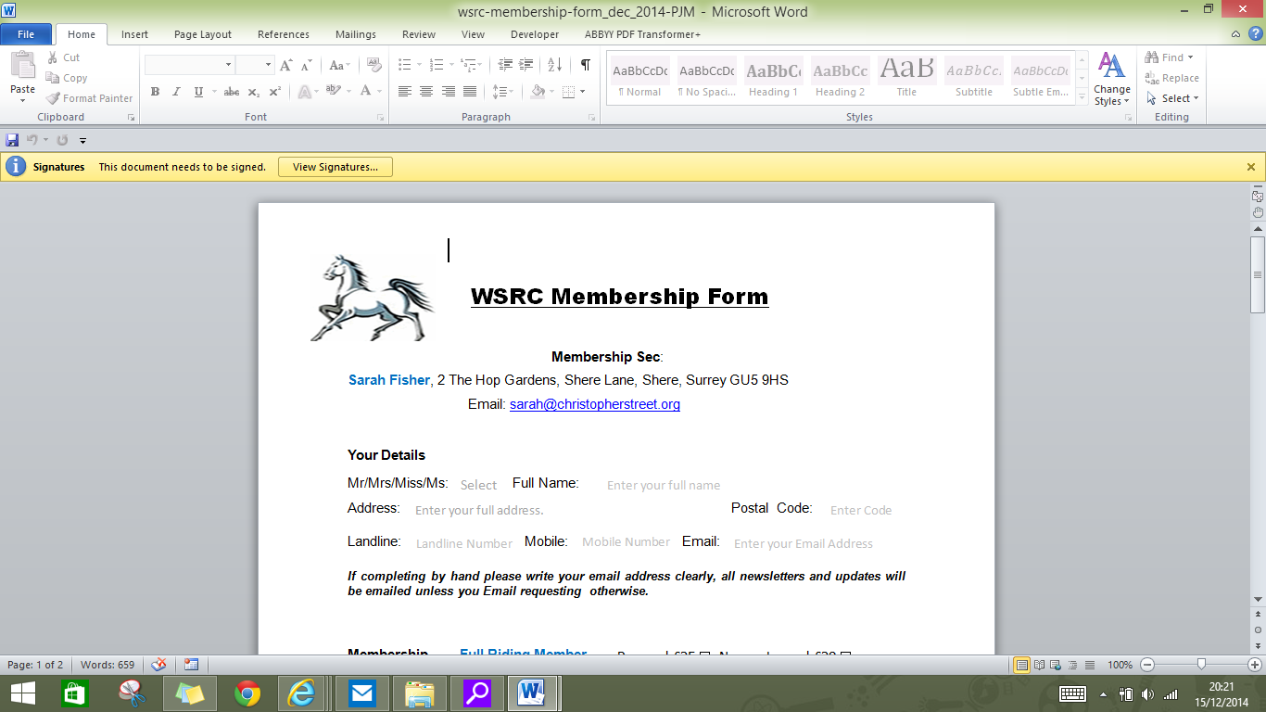
The following page will be displayed. Select “Sign” from the drop down list
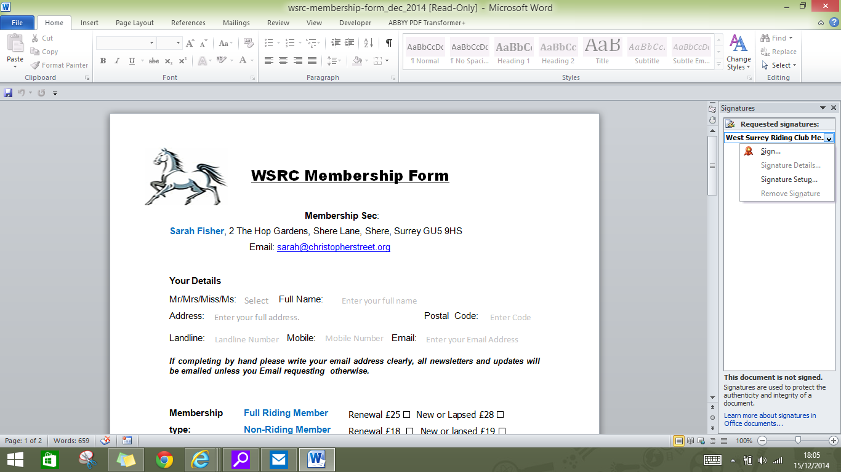

The following page will be displayed, click “OK”
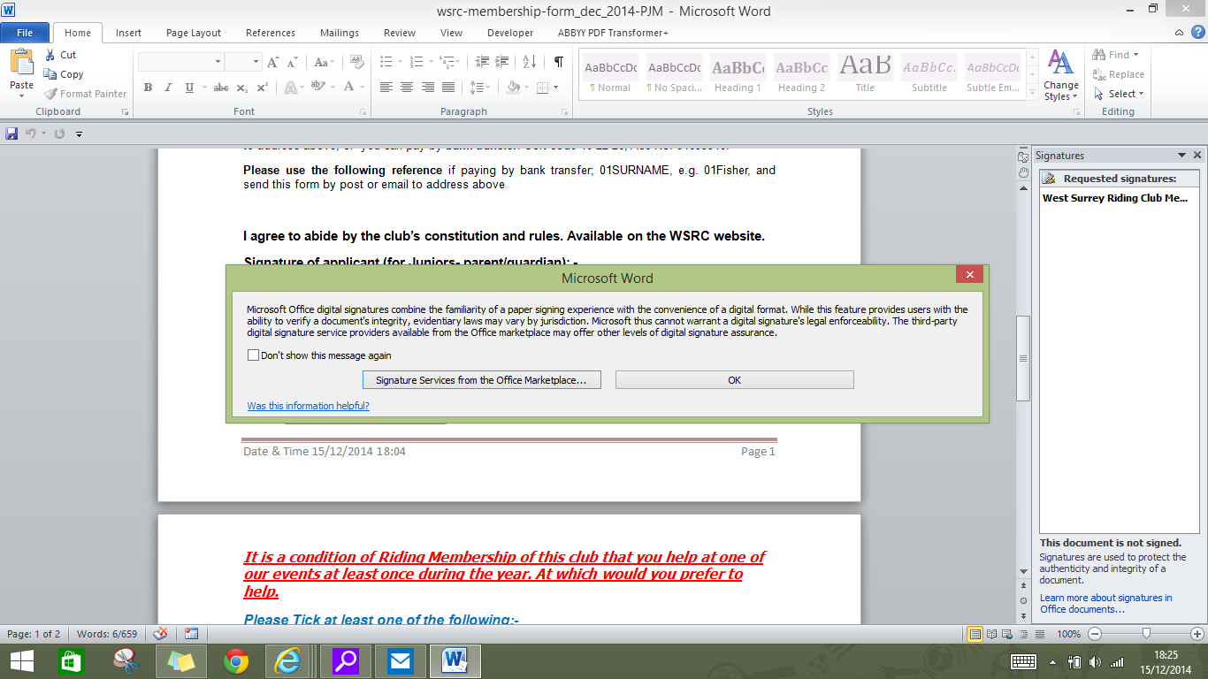
The following page will be displayed, click “Select Image”. This will open Windows File Explorer and display the Folders on your PC. Please navigate to the folder where you saved your signature and select it.

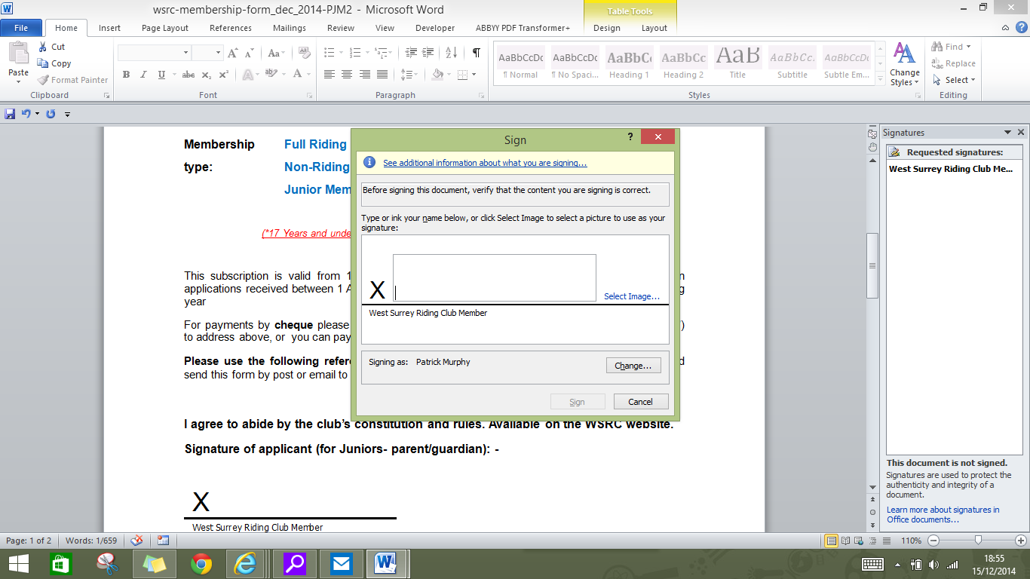

After you have selected your Signature the following screen will be displayed, click “Sign”
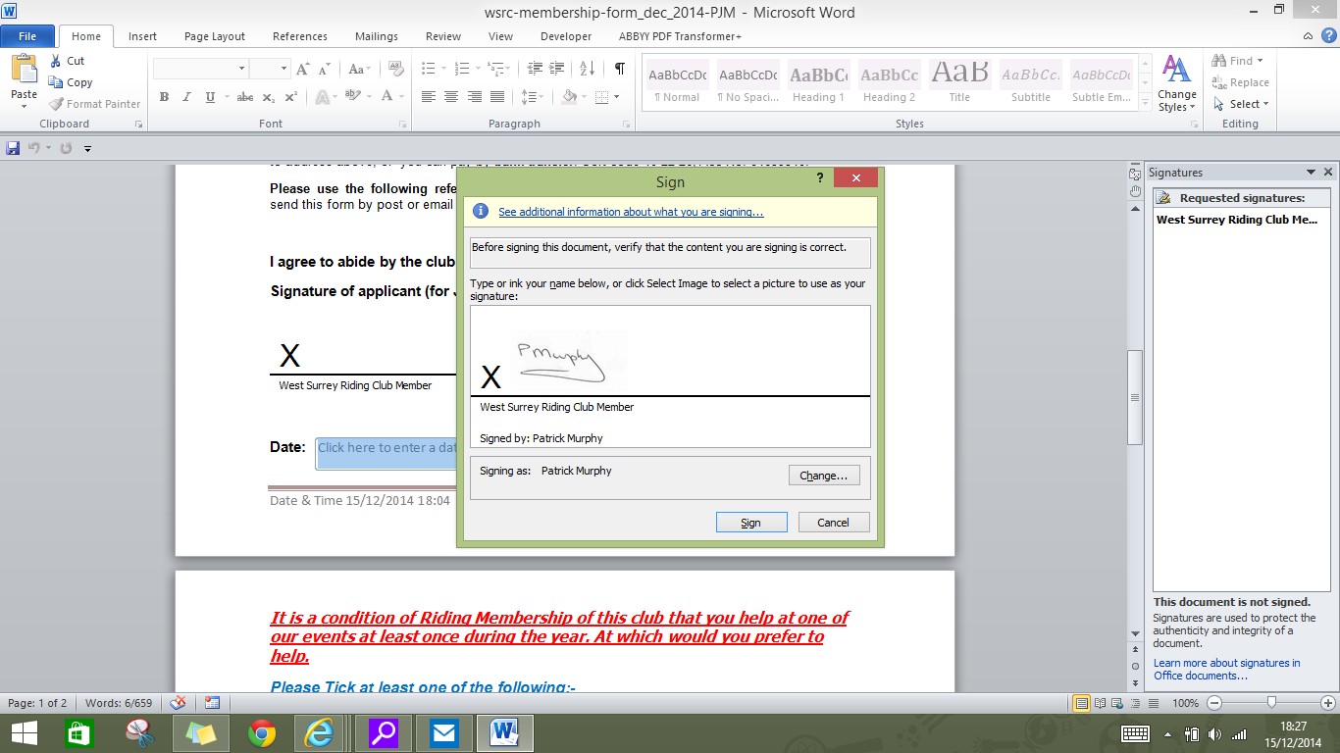
Click “OK” to the message displayed and the following screen will be displayed and the Membership Form has your signature assigned to it.
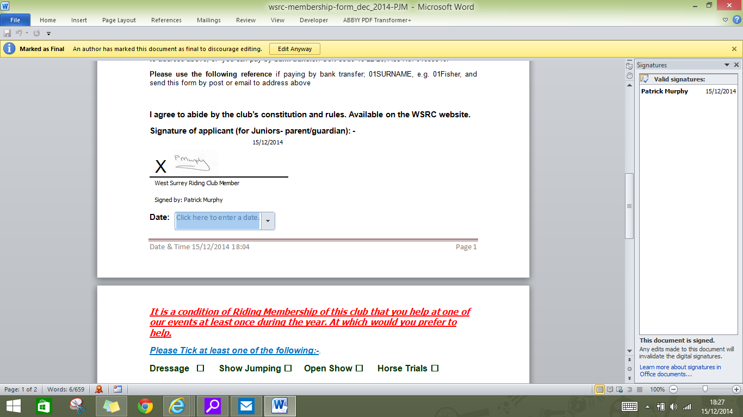

On completion of the Form please Email to the Membership Secretary as specified in the Membership Form.

