West Surrey Riding Club Newsletter – July 2012
www.westsurreyridingclub.co.uk and on Facebook

We normally start this newsletter with a message from our Chairman, however, she has been unwell and so sadly there is just a note from me!

We have had a great summer so far with loads of Club activities and a fantastic effort from our new Team Managers and Club Activities Managers – so a big THANKYOU to Pat, Lynn, Lisa and Marilynn! And also thanks to all our members who have participated and supported them but volunteering for teams and coming along to the instruction and social events.

Also, you might notice that this newsletter isn’t quite up to standard in terms of presentation....my apologies for this, but I am just filling the gap between Helen Kendall handing over responsibility for the newsletter production to Ro Major. Our thanks to Helen who has had to step down owing to increasing workload and our thanks to Ro for taking on yet more responsibility for the Club.

There will be a new vacancy on the Committee from the end of the year as Michelle Matthews has sadly decided to hang up her calculator after many years of sterling service to the club. So if anyone has bookkeeping experience and would like to join the Committee please contact Vicki as soon as possible as this is a vital position and we would like to make a smooth hand over if at all possible.

That’s it for now and leave you to read the interesting stuff!

Cass Lillington

MEMBERSHIP

A warm welcome to our new members who are Charlotte Taylor, Anne Limbach, Silke Otremba, Jackie Ellis, Holly Maden, Anna von Radowitz, Steph Chamberlain, Ella Jarvis and Olivia Scott. We look forward to seeing you at our events and don’t hesitate to contact any committee members if you have any questions or concerns.

If you hear of anyone thinking of joining the club they may be interested to know that new membership applications received between 1st August and 31st October will be valid through until 31st October 2013 which gives up to 15 months membership for the price of 12. The normal / renewal membership year is 1st November to 31st October.

FACEBOOK QUICK GUIDE

With this Newsletter we have attached a Quick Guide to joining the WSRC Group on Facebook. We appreciate that not all our members wish to use Facebook but we have found this is a valuable communications tool for keeping members up to date with activities in the club. We would recommend that all members do register and we think you will be pleasantly surprised at is simplicity but effectiveness. We will obviously continue to use our Website and Email for communications. If you have any feedback or ways you think we could improve our communications can you please email any of the committee, their email addresses can be found on our

Website: - http://www.westsurreyridingclub.co.uk/contact.html

TEAM EVENTS

Horse Trial 19th May at Snowball Farm

Lynn Roberts on Phone Tom, Charlotte (Lottie) Taylor on Pop Idol & Patrick Murphy on Bartley Bay

I struggled to get a team for the Horse Trials at Snowball Farm and had to enter a team of 3 instead of 4! Lynn, Lottie and I foolishly went to walk the course on the Friday Afternoon/Evening, A3, M25 & M4 as you will appreciate was not a good place to be that time of day especially on a Friday, it was a long evening but we passed the time with some deep intellectual conversations! The schedule had said the course would be 80 – 85cm. When we walked the course, to our horror, they were all a full on 90cm with some quite demanding fences, in fact it was the BE90 course! Poor Lynn was entered on Tom who had only just come over from Ireland and as an ex racehorse had done very little if any Eventing!

We had an early time so set off in the early hours feeling a little apprehensive, it didn’t help matters that when we arrived there competitors were complaining about the XC and some were withdrawing!

We all did a reasonable dressage test and Lottie managed to get a few more points than Lynn & I. The warm up for the Show jumping was in an outdoor Sand School and I think they were trying to get in the Guinness Book of Records for how many people they could get in there and have people jumping the practice fences without an accident! Between us we only got 12 faults but I had time faults as Bart decided to spook in-between every jump.

The XC had been causing some problems and a number of competitors had refusals / been eliminated at fence number 4 which was a wagon and quite daunting. With a bit of encouragement from Lynn I headed off on the XC and went clear but had time faults for going to slow. Next went Lottie who did a fantastic clear on Poppy and within time. We were all worried about Tom as this was all new to him. He proved to be a little star and very brave and got ¾ away around before Lynn, sensibly, pulled him up as he was getting very tired and was in danger of hurting himself as he would of carried on jumping!

Although we didn’t get placed for a team that was pulled together at the last minute we did really well

and had a really enjoyable day.

Thanks to Holly for grooming for the team, giving us moral support and for loaning her super horse Poppy to Lottie to ride. Looking forward to the next event!

Pat – Horse Trials Team Manager

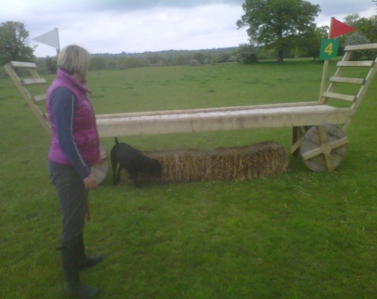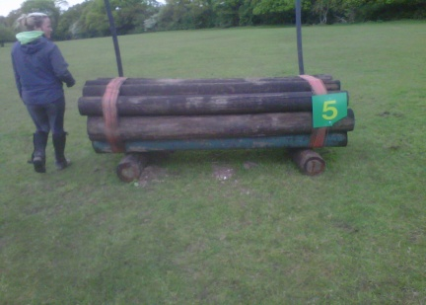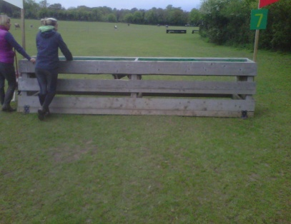

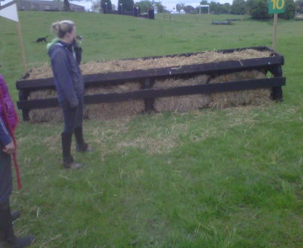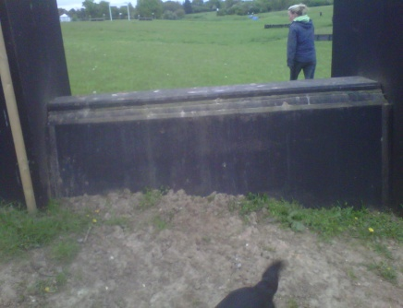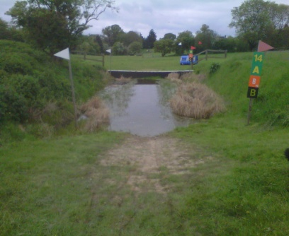

Please note I have loaded pictures of all the fences onto Facebook under Tab Files as a Zip file. If you want to view them then download the zip file to your computer and then open the first file to view all fences. Do not Open straight from Facebook as it will only let you look at the first Fence!

L&SE Show Jumping Qualifier 29th April

Team - Anna Prouty on La Gio, Lisa Vanoli on Ukate, Yvonne Little on Waterford Bay, Harriet Wilks on Santa Cruz

Individual – Patrick Murphy on Bartley Bay.

This was our first event of the year and we offered potential Team Competitors a subsidised Jumping session with Fiona Breach which was very well received. If you can cast your memory back that was the week and weekend of torrential rains and storms! We kept our spirits high and were keen to compete right up to the very last minute. Due to the adverse weather conditions with flooded roads the Team decided at the 11th hour that we didn’t want to risk injury to our horses and withdrew from the event.

Lynn & Pat – Joint Show jumping Team Manager

L&SE Show Jumping Qualifier 9th June

We had a great response to this event and sent two teams. As this was a L&SE Qualifier we were allowed to have a Junior in each team, we in fact had 3 Juniors that wanted to compete for the club! This event consisted of two rounds, the first round at 80cm and the second at 85cm. Both teams did really well and we only had a few fences down & a couple of stops. Two competitors stood out on the day Natalie Mendolssohn who rode a very professional second round and unfortunately had a stop at the second to last fence but jumped it confidently on the second attempt. Phone Tom was unfortunately lame on the day so Vanessa Bertrand had to ride one of Lynn’s horses that had only come over from Ireland the day before which she had never ridden before, although we understood the mare (Honey) jumped we weren’t sure! In the first round although Vanessa went clear she literally carried Honey over a couple of jumps and got a big cheer from the team when she jumped the final fence with a clear round! The second round was far more polished and Honey looked like a jumping pony! Although the Blue Team only ended on final score of 4 faults with 3 other teams we were placed 4th as we had a slower combined time. We still qualified so a great result for the club! We rounded of the day with a couple of bottles of wine (thanks to Silke & Sarah) and a picnic. It was a very sociable and friendly event and I am sure everybody enjoyed the day.

WSRC Reds WSRC Blues

Holly Maden on Pop Idol Natalie Mendolssohn on Rusper

Lynn Roberts on Cooley’s Surprise Silke Otremba on Bartley Bay

Vanessa Bertand on Honey Patrick Murphy on McGinty

Anna Prouty on La Gio Sarah Fisher on Espionage

Lynn & Pat – Joint Show jumping Team Manager

Dressage 17th June Bookham Riding Club – National & L&SE Qualifier

West Surrey Riding Club managed to send 2 teams to Bookham for the National and London & South East qualifiers; unfortunately I had to make a few last
minute changes, poor Judith’s horse, had a sore foot as did my horse Tom. So at the eleventh hour I had to swap mounts and Erica Lawrence saved the day and stepped in with Finnin.

So after all the last minute dramas that frequently happen where horses are involved, we were still able to compete two teams at the event!

Red Team Lynn Roberts on Cooley Suprise ,Lisa Fahy on Salviano,
Maralyn Dunham on Grayswood Pandora, Silke Otremba on Bartley Bay

Blue Team Sylvia Laney on Serena, Erica Lawrence on Finnin,
Jenny Tulley on Lazy Acres Hurricane, Natalie Mendelssohn Rusper

Due to the heavy rainfall it was touch and go whether the competition went
ahead. Fortunately, the ground at Bookham has good drainage and with rain forecast for Sunday afternoon the dressage ,sensibly, was moved from the afternoon to the morning. Although this was an organiser’s nightmare the event ran very smoothly and people commented on what a relaxed and friendly venue it was!

We all enjoyed the day and to top it off West Surrey did extremely well and the Red Team finished 2nd overall, just missing out on qualifying for the National final! Thinking things couldn’t get any better Lisa Fahy finished top in her section and top overall, so she qualifies as an individual to represent West Surrey at the Nationals. Well done Lisa! Young Natalie Mendelssohn, our only junior, was close on her tail and finished 2nd behind Lisa in their section! I finished 2nd in my section and 2nd overall. The remaining team members rode very good tests and there were marginal differences in their scores, so all in all a fantastic result for the club!

A special thank you to Judith and Julie for coming along and giving the Teams moral support and for reading tests and videoing!

Lastly, a very big well done to all team members and many thanks for all your support.

Looking forward to our next event at Newlands Corner on the 8th July

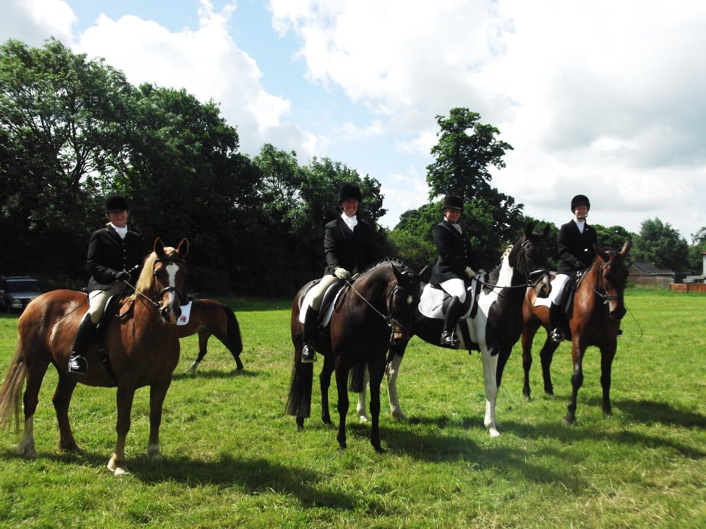

Lynn – Dressage Team Manager

All Team Events

We are always looking for new Club Members to join the Teams; the main objective is for the Teams to have a good time and not to feel under any pressure to win, obviously if we do that is a bonus! If you would like to discuss further please do not hesitate to contact Lynn or Pat for the respective discipline.

Lynn - Dressage Team Manager

Lynn & Pat – Joint Show jumping Team Manager

Pat – Horse Trials Manager

SUMMER DRESSAGE SERIES

To be held at Kilnhanger Stables GU5 9EW by kind permission of Lynn Roberts

Including an optional practise session with Catriona Moorwood on the weekend before the competition.

JULY Dressage Practice session with Catriona Moorwood on Sunday 8th July @ Heath Cottage GU5 9DP

Dressage Tests @ Kilnhanger Stables GU5 9EW on July 15th
Walk & Trot A
Prelim 12
Novice 30
Elementary 42

AUGUST Dressage practice session with Catriona Moorwood on SATURDAY 11th August @ Heath Cottage GU5 9DP

Dressage Tests @ Kilnhanger Stables GU5 9EW on August 19th
Walk & Trot B
Prelim 14
Novice 34
Elementary 44

SEPTEMBER Dressage practice session with Catriona Moorwood on SATURDAY 8th September

Dressage Tests on 16th September

Walk & Trot A
Prelim 18
Novice 28
Elementary 42

CONDITIONS OF ENTRY

- The Walk and Trot test is for inexperienced riders or young/inexperienced horses. You cannot enter W&T if you have previously been W&T Champion or Reserve Champion (horse and rider combination) or if you are competing in the Prelim competition on the same horse unless you enter Prelim HC.
- Prelim Section A - For horse and rider combinations who have not been placed in an Open Prelim or higher competition or who have been Champion or Reserve Champion in a previous closed Club Prelim competition.
- Prelim Section B - For established combinations of horse and rider – all members are eligible to enter.
- Novice and Elementary – all members eligible to enter. These two tests will be run as a combined class with the final percentage denoting the winners.

PRIZES
Points will be awarded up to 6th place in each competition of the series. The overall winners of each section in the series will win free membership of the Riding Club for the next membership year. The reserve champion for each series will win free instruction with the club up to the value of £15.
RULES
No plaiting is necessary but the usual Riding Club rules on dress, tack etc. will apply. Please note this particularly covers wearing a hat of the current standard with a three point harness attached.
ENTRIES
All entries must be accompanied by the appropriate fee. Cheques should be made payable to WSRC.
Entries will not be refunded unless the event is cancelled by the organisers due to adverse weather conditions or lack of entries.
Entries for both tests and Catriona practise sessions should be sent to:

Helen Kendall, Greenside Cottage, The Green, Shamley Green, Guildford, GU5 0UA.

The test times will be available on the club website www.westsurreyridingclub.co.uk
on the Thursday evening before the test. Alternatively you can ring Helen that evening between 8 and 9pm on 01483 890217. Tests are available from the British Dressage website www.britishdressage.co.uk

2012 Summer Dressage
Entry Form
Entry Fee : £7.00 per test

Sunday 15th July, 2012 Venue: Kilnhanger Stables Entries Close: Tuesday 10th July

Test | Horse | Section | Rider
Walk and Trot A
Prelim 12
Novice 30
Elementary 42
Signed | Tel: | EMail

Sunday 19th August, 2012 Venue: Kilnhanger Stables Entries Close: Tuesday 14th Aug

Test | Horse | Section | Rider
Walk and Trot B
Prelim 14
Novice 34
Elementary 44
Signed | Tel: | EMail

Sunday 16th Sept, 2012 Venue: Kilnhanger Stables Entries Close: Tuesday 11th Sept

Test | Horse | Section | Rider
Walk and Trot A
Prelim 18
Novice 28
Elementary 42
Signed | Tel: | EMail

INSTRUCTION
Since joining the WSRC and then the Committee I’ve been give the honour of arranging the Club Instruction. This year I have introduced some new instructors as well as keeping the older ones you all know and trust! All the latest news and feedback about the instruction is on our Facebook page.
Ali Cookson is one of our new instructors. Everyone has loved their lessons and gained so much. Ali is very focused on the “traditional and correct” training of horses and all members have come away impressed how much their horses “changed” in their ½ hour lessons. It’s also nice to be inside sheltered from the rain – or heat as was the case for the last lesson! Ali has kindly agreed to carry on her instruction with the club and the next lessons are to be held on Thursdays 20th and 27th September from 10:30 to 14:00.
Hinda Inglis has been as popular as usual – again gaining the most out of the horse and rider in the ½ hour lesson time. For our lessons in June we re-introduced “Pole Dancing” which was great fun! For those of you that do not know what this entails it’s not as bad as it sounds, the poles are left on the ground – no air between them and the surface of the school! Hinda puts them in measured places around a 10m, 15m or 20m circle or straight lines to help the horse to lengthen or shorten and also to help with lateral work. Hinda even managed to make two ex-racehorses (who are not known for being relaxed) calmly trot over the poles and do the exercises in a shared lesson! Hinda has kindly agreed to do some flatwork lessons at Whipley Manor Farm, Cranleigh on Saturday 28 July from 10:00 to 13:45 (¾ hr individual or paired sessions). I have also managed to book Hinda up to do some show jumping lessons on Saturday 18th August at Hurtmore Cottage, Farley Heath from 10:00 to 14:00 – groups of 3.
Fiona Breach has been helping some members of our SJ and Eventing teams and I have arranged for her first open training sessions for our Club on 7 July up at Mayor House Farm, Albury. I do hope that they prove to be popular as Fiona is willing to do more for us! There are two lessons this time at up-to 2’3” and then 2’9” and over. I hope everyone has fun and enjoys leaving the ground on purpose!
Rebecca Harvie is running our first XC schooling on 14 July at Heath Farm, Munstead. At the time of going to print the take-up has not been that good – only 3 members willing to try it out. So unless there is a sudden rush we may have to cancel which will be a shame.
I have spoken to Kathy Merrick about organising some training for people who would like to take part in competitions for dressage to music either as an individual or in pairs plus also forming a team of six to take part in Rural Riders competitions (no music). Please let me know if you’d be interested in taking part in the above and we’ll see what we can arrange. It sounds like fun! Also if we do form a Rural Riders Ride we’ll need a 60 x 20 arena to practise in – does anyone know of one we can use – thank you?
The booking form for all instruction is on the website. Please use this when you book lessons not scraps of old paper! Also please fill in ALL the contact details in case I have to call you/email at the last minute due to change in circumstances. Also it has the declaration to say that you agree with the booking conditions!
Many thanks for your support and I hope you all carry on enjoying the Instruction sessions that I put on for our Club.
Lisa Fahy

PAST EVENTS
The big event of the summer was our Open Show.

The day dawned with a very average forecast and yours truly was very nervous that we would be sitting getting soaked in a big empty field watching the rain while all our competitors stayed at home warm and dry! How wrong could I be. We were unbelievably lucky with the weather, which stayed dry all day, and the show ground was busy all day. We even had to close some classes because we had too many entries and we also made a modest profit for the Club coffers to help fund us through the year.

We had lots of nice feedback from competitors and I hope that most of those who came had a good day which was both fun and rewarding. Most of the credit for this must go to the helpers and judges who gave up precious time at the weekend both to set up the showground and then help run the show on the day and pack up afterwards. Without you guys we couldn’t run the show so a HUGE THANKYOU!!

We did have one setback on the day, I was expecting the photographers in the morning (RPE Events) but they never arrived. Needless to say I wasn’t impressed and contacted them as soon as I got home, only to discover that they had been involved in a serious car accident. They were on their way to the showground at the time and all four who were in the car had to go to hospital and were really in quite a bad way. Needless to say I felt awful about complaining and immediately sent them a card on behalf of the Club. Which is why we don’t have any pictures for competitors but luckily Chris Lee was at the Trec ring so he has taken some pictures which you can access from the website.

The full results for the day are up on the website and the only disappointing note in a really successful day was the lack of Club members entering the show. I don’t know why this is, so if anyone would like to let me have any ideas to help promote the show to you all please let me know.

Cass

DATES FOR YOUR DIARY

JULY

14th WSRC Rebecca Harvie XC schooling at Heath Farm, Munstead
15th WSRC Summer Dressage at Kilnhanger
22nd BRC Team SJ at Hickstead. Teams of 3 Seniors, Juniors / Novice, Intermediate and Open heights
28th WSRC Hinda Inglis flatwork at Whipley Manor Farm

AUGUST

3rd - 5th SEIB National Horse Trials Championship, Aston-leWalls, Northants. NN11 6RT
11th WSRC Practise session for Dressage with Catriona Moorwood
18th WSRC Hinda Inglis S/J at Hurtmore Cottage
19th WSRC Summer Dressage at Kilnhanger

SEPTEMBER

8th WSRC Practise session for Dressage with Catriona Moorwood
16th WSRC Summer Dressage at Kilnhanger
15th -16th NAF National Championships, Lincolnshire Showground, Lincoln LN2 2NA
20th WSRC Ali Cookson Clinic
27th WSRC Ali Cookson Clinic
30th L&SE Horse Trials, Riding Test, Show Jumping & Dressage Championships
Sparright Farm, Rackham

OCTOBER

6th -7th Dressage to Music Championships and Quadrille Selection, Aintree International Equestrian Centre, Liverpool L9 5AS
21st L&SE Dressage to Music Championships, Sands Farm

COMMITTEE

Chairman
Vicki Glynn
Email: VickiGlynn@hotmail.com
Tel: 07768 237032

Hon Secretary
Cass Lillington
1 Knowle Cottages,
Knowle Park
Knowle Lane
Cranleigh GU6 8JL

Email: cass.lillington@btinternet.com
Tel: 07850 387997
01483 267161

Hon Treasurer
Michelle Matthews
Crawick
13 Mapledrakes Close
Ewhurst GU6 7QR

Email michelleheathermatthews@yahoo.co.uk
Tel: 01483 267790

Bridleways
Katherine Manson
29 Halfpenny Close
Chilworth GU4 8NY

Email: katherine.manson@environment-agency.gov.uk
Tel: 01483 569642

Membership
Julie Rowley
Elstowe, River Lane,
Fetcham KT22 9RJ

Email: julierowley@btinternet.com
Tel: 01372 377172

Instruction
Lisa Fahy

Email: lisamfahy@yahoo.co.uk
Tel: 01483 860585
Tel: 07740 625039

Horse Welfare Adviser
Kathy Merrick

Email: kathymerrick@tiscali.co.uk
Tel: 01483 898305

Newsletter/Points/Trophies
Ro Major

Email: ro@jhaconsult.co.uk
Tel: 01483 200560

Area Respresentative
Cathy Hughes

Email: c.hughes@vla.defra.gsi.gov.uk
Tel: 01483 770943

Social Events
Marilyn Dunham

Email: marilynndunham@hotmail.com
Tel: 01483 203180

Teams

Pat Murphy – Horse Trials
Email: patmurphyhome@aol.co.uk
Tel: 07971 064339

Lynn Roberts – Dressage
Tel: 07977 048714

Pat and Lynn also cover showjumping teams at present

